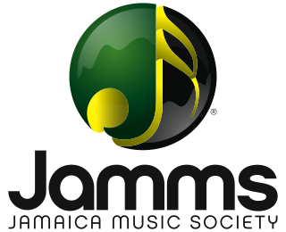
LICENSE APPLICATION FORM JPP10

For Event Promoters/Organizers (Party, Stage Show, Concert, Festival, Round Robin, Carnival, Fete, Session)
SECTION A – GENERAL INFORMATION DATE:

CONTACT PERSON: BUSINESS NAME:

TELEPHONE #: TELEPHONE #:

BUSINESS ADDRESS: EMAIL:

SECTION B – SPECIALLY FEATURED ENTERTAINMENT

EVENT # 1

Event Particulars | Type of Event (e.g. Party, stage show, session, round robin, festival, fair, exhibition) | No. of Such Events Per Year | - Avg. Attendance per event  - Entry Fee  - Event Duration
- Name of Event

- Date of Event |  |  | - J$
- Name & Address of premises where event will take place |  |  | - ………hrs

Notes:
- Specially Featured Entertainment – Where sound recordings are used as a main attraction but not necessarily the main attraction.
- Average Attendance – This should include all person admitted to the area where sound recordings are being played as specially featured entertainment whether or not they have paid an admission fee or are members or guests.

SECTION C – FURTHER INFORMATION

Please provide details of any additional use of sound recordings not covered in previous sections.
……………………………………………………………………………………………………………………………………..
…………………………………………………………………………………………………………………………………......
………………………………………………………………………………………………………………………………………

NAME AND SIGNATURE OF APPLICANT/AUTHORIZED OFFCIER…………………………../…………………………………

POSITION OF SIGNATORY: ……………………………………………..

DATE: ………………………………………………………………………

